Physical E duc at ion C u r r ic u l um G u ide

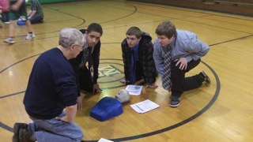
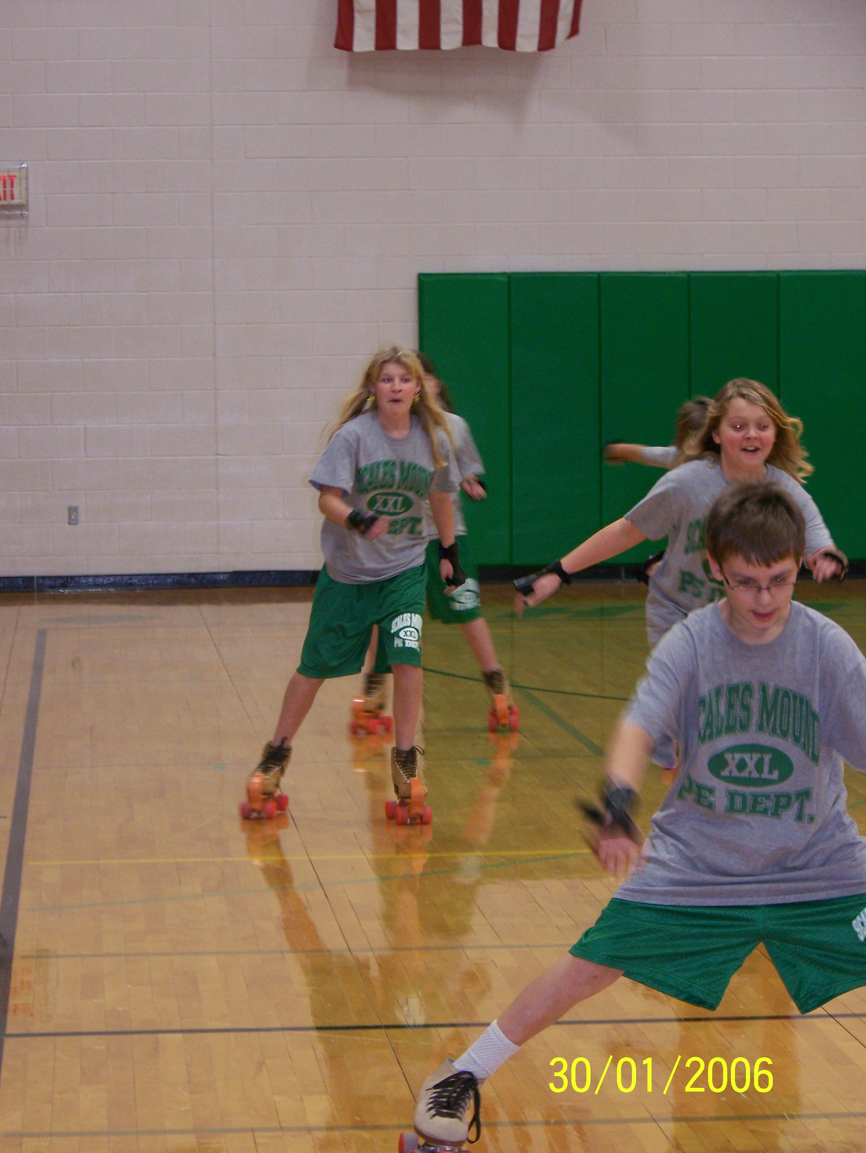

Community Unit School District #211

Scales Mound, Illinois

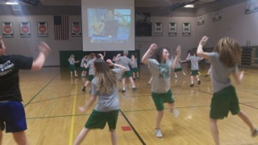

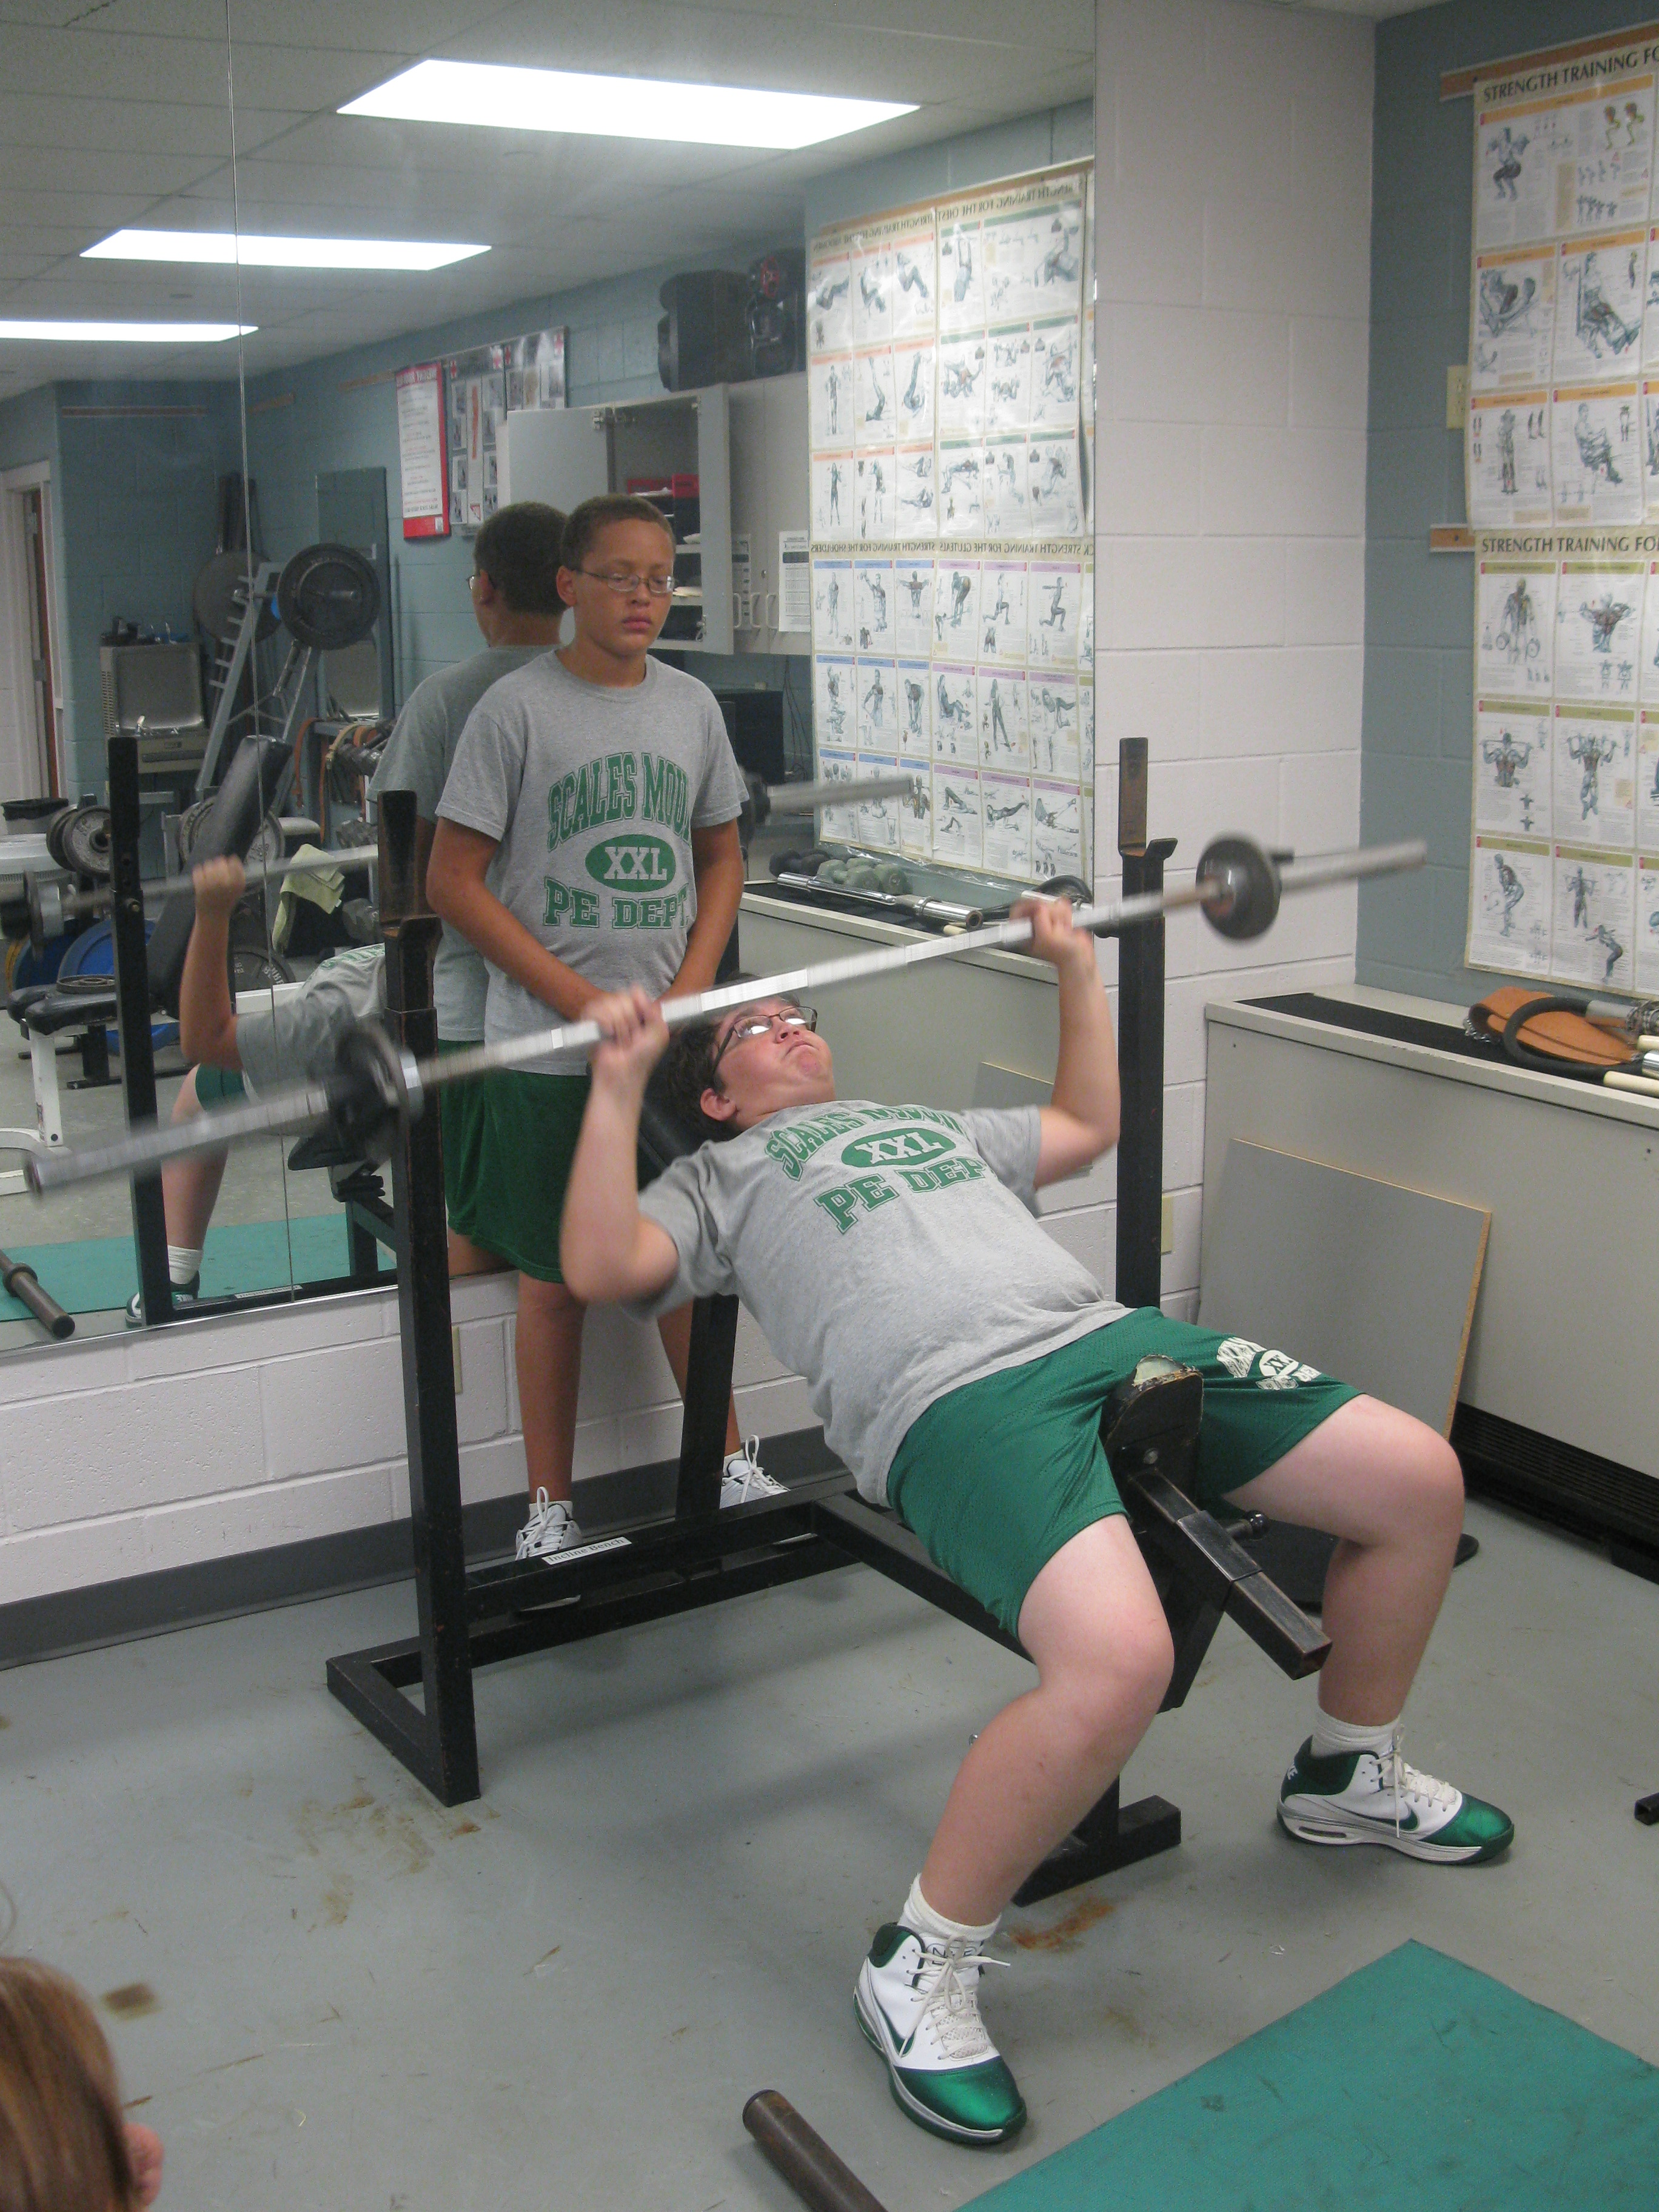

Curriculum for Scales Mound School District #211 (CUSD#211) Elementary/Jr. High

Physical Education Program

Jordan Williams- (Grades Pre-K-8th P.E.)

210 Main Street

Scales Mound, IL 61075
jordanwilliams@scalesmound.net
815-845-2215 ext. 319

Dave Wiegel- (Grades 9th-12th P.E.)

210 Main Street

Scales Mound, IL 61075

Davidwiegel@scalesmound.net
815-845-2215 ext. 219

Scales Mound Physical Education Mission Statement
Our purpose in Physical Education is to promote lifelong learning in both the cognitive and physical domains. Through motivation and encouragement, students will be introduced to a life of self-improvement and wellness. We strive to build positive self-esteem by teaching communication, cooperation and decision-making skills. These valuable life lessons will prepare students physically and mentally for the 21st Century. Our philosophy is to encourage students to be active and fit in the moment and more importantly, to teach concepts, strategies and skills that allow students to be active for a lifetime.

I. Introduction to the Curriculum Guide

The following pages contain an overview of the Physical Education Program for grades Pre-Kindergarten through Eight grade for CUSD#211 in Scales Mound, Illinois. The purpose for this curriculum guide is to give clear focus for the physical education program.
This curriculum has embedded both the National Association for Sport and Physical Education (NASPE) Standards and the Illinois State Standards for Physical Development as the primary steering tenants for the entire program. The guide identifies a variety of important elements, which steers and supports a quality physical education program

II. Gene r al Safety Guidelines

Safety is a primary concern in all physical education classes. The following list includes some general safety and common sense practices that are important within our physical education program.

Students will respect themselves, their classmates, their teachers, and the equipment and facilities.

Students are encouraged to wear tennis shoes suitable for Physical Education movement activities for safety and efficiency of movement.

Safe movement practice will be emphasized in all classes.

Students must ask permission if it becomes necessary to leave the gymnasium, activity space, and/or the classroom during Physical Education Class. Safe supervision will be continuously maintained.

III. National Standa r ds / State G oals / B enchma r k Samples

Both the National Standards and State Goals for physical education are in place to help drive and support a quality physical education program and all physical education lessons experiences. The following standards are listed with corresponding sample grade level benchmarks as sample guideposts for elements that will be addressed across the grade ranges in all the domains of learning.

N a t ion a l St a n d a r ds w i th Sa mp le G r a d e R a nge B e n c h ma r k s

N a t ion a l St a n d a r d 1 (Sta te G oa l 19) - Demonstrates competency in motor skills and movement patterns needed to perform a variety of physical activities.

K-2 Benchmark Samples
Performs a simple dance or rhythm step pattern in keeping with a specific tempo
(e.g. Slow-slow, fast- fast).
Travels forward and sideways, changing direction quickly in response to a signal or obstacle using a variety of locomotor skills.
Drops ball and catches it at peak of bounce.

3-6 Benchmark Samples
Balances with control on a variety of body parts and/or objects.
Develops and refines a gymnastics sequence (or creative dance sequence)
demonstrating smooth transitions.
Dribbles a ball while preventing an opponent from stealing the ball.

N a t ion a l St a n d a r d 2 (State Goal 19) - Demonstrates understanding of movement concepts, principles, strategies, and tactics as they apply to the learning and performance of physical activities.

K-4 Benchmark Samples
Identifies correctly body planes (i.e. front, back, side). Identifies correctly body parts (i.e. knee, foot, and arm).
Gives the best effort consistently when trying new and hard task.

5-8 Benchmark Samples
Identifies and demonstrates key elements of a proper grip when holding a racket to perform the forehand strike.
Accurately recognizes the critical element of a catch made by a fellow student and provides feedback to that student.
Identifies physical and psychological benefits that result from long-term participation in physical activity.

N a t ion a l St a n d a r d 3 (Sta te G oa l 20) - Participates regularly in physical activity.

K-4 Benchmark Samples
Engages in moderate to vigorous physical activity on an intermittent basis. Engages in a variety of locomotor activities (e.g. hopping, walking, jumping, galloping, and running).
Participates in chasing and fleeing activities. Engages fully in all movement activities in class.

5-8 Benchmark Samples
Consciously chooses to participate in moderate to vigorous physical activity outside of physical education class on a regular basis.
Chooses to participate in structured and purposeful activity in class consistently. Regulates physical behavior by using appropriate cues and movement principles.

N a t ion a l St a n d a r d 4 (Sta te G oa l 20) - Achieves and maintains a health-enhancing level of physical fitness.

K-4 Benchmark Samples
Demonstrates sufficient muscular strength to be able to bear body weight for climbing, hanging, and momentary body support on the hand

Sustains activity for increasingly longer periods of time while participating in various activities in physical education.

5-8 Benchmark Samples
Participates in selected activities that develop and maintain each component of physical fitness (health and skill related).
Runs the equivalent of two laps around a regulation track without stopping. Participates in activities designed to improve or maintain all of the following: muscular strength, endurance, flexibility, cardio respiratory, and body composition both during and outside of school.

N a t ion a l St a n d a r d 5 (Sta te G oa l 21) - Exhibits responsible personal and social behavior that respects self and others in physical activity settings.

K-4 Benchmark Samples
Practices specific skills as assigned until the teacher signals the end of practice. Follows directions given by instructor throughout the entire class activity.
Uses equipment and space safely and properly.

5-8 Benchmark Samples
Cooperates with all class members by taking turns and sharing equipment. Regularly encourages others and refrains from put-down statements. Remains on task in-group activity without close teacher monitoring.

N a t ion a l St a n d a r d 6 (Sta te G oa l 21) -Values physical activity for health, enjoyment, challenge, self-expression, and/or social interaction.

K-4 Benchmark Samples
Willingly tries new movement and skills.
Continues to participate when not successful on the first try. Identifies several activities that are enjoyable.

5-8 Benchmark Samples
Explains that skill competency leads to enjoyment of movement and physical activity.

Interacts with others by helping with their physical activity challenges
Invites all students, regardless of ability, to participate in physical activities.

Grading Rubric for PreK-3
E S N
Consistent daily Needs some reminders to Poor engagement, little or no
participation, displays participate, puts forth movement during activity, quality movement minimum effort, numerous excuses for attempts during contributes little to inactivity, socializing activities, stays on task, partner and small group interferes with participation. maintains solid play, does not work hard
engagement to support enough to improve personal fitness. personal fitness
Consistently follows Inconsistently follows Uncooperative, bends rules to
rules, good attitude, rules, plays well most of suit self, displays
displays cooperation, the time, or when being inappropriate frustration and and works hard for self observed by teacher. anger towards others,
and others. celebrates mistakes of others.
Supportive of all Needs some reminders Needs constant reminders to
students in class follow to: listen and follow stay on task and follow directions, active directions, to follow safety directions. Talks during listener, follows safety rules, to use equipment directions, ignores safety rules, treats equipment appropriately, and to stay rules, argues with others with care, stays on task on task during activity during activity, negative during activity. comments directed towards
others.
Always prepared for Almost always prepared Generally prepared for class class activity; i.e. tennis for daily PE activity; i.e. with tennis shoes, proper PE
shoes, proper PE tennis shoes, proper PE clothing,
clothing. clothing.

Daily G r ading R ub r ic for 4th-12th
3 2 1 0
Models a high level of participation and engagement, self- motivated, committed to improving personal fitness by continuous participation, encourages others.

Models exemplary sports like behavior and positive attitude, accepts winning and losing respectfully, shows respect of opponent.
Always prepared for class activity; i.e. tennis shoes, proper PE clothing.

Respectful of all classmates, helps others when needed, positive and fair game play,
follows safety rules, treats equipment with care, models self-control.
Displays good level of participation, displays quality movement during activities, stays on task, maintains solid participation to support personal fitness.

Consistently follows rules, good attitude, displays cooperation, and works hard for self and others.

Almost always prepared for daily PE activity; i.e.: tennis shoes, proper PE clothing.
Supportive of all students in class, follow directions, active listener, follows safety rules, treats equipment with care, stays on task during activity.
Needs some reminders to participate, puts forth minimum effort, contributes little to
partner and/or small group play, does not maintain sufficient engagement to support or improve personal fitness Inconsistently follows rules, plays well when on winning team or when being observed by teacher.

Generally prepared for class with tennis shoes, proper PE clothing,

Needs some reminders to: listen and follow directions, to follow safety rules, to use equipment appropriately, and to stay on task during activity
Poor effort as evident by little or no movement during activity, numerous excuses for inactivity, socializing interferes with participation.

Uncooperative, bends rules to suit self, displays
inappropriate frustration and anger towards others, celebrates mistakes of others.

Seldom prepared with tennis shoes, PE clothing.

Needs constant reminders to stay on task and follow directions. Talks during directions, ignores safety rules, argues with others during activity, negative comments directed towards others.

B e h avior C on c e r ns: In addition to the above scoring rubrics, the following list includes the behavior concerns, which are priority items in Physical Education Classroom.

1. L istens attentively
2. Follows di r ections
3. Works carefully
4. Works independently
5. Returns Homework
6. Follows P E routines & rules
7. Respects classmates and teacher
8. Respects rights / p rope r ty of the rs
9. Resolves conflict without violence
10. Works well with others
11. Speaks at appropriate times
12. Stays on task & is quiet at appropriate

P rogr am Content Pre-Kindergarten/Kin de rga r ten
W ee k | D ate | Cu rriculum Outline for K inde rga r ten
1 |  | Establish Learning Environment
2 |  | Space Awareness
3 |  | Space Awareness & Effort & Relationships
4 |  | Traveling
5 |  | Traveling
6 |  | Throwing Underhand Focus
7 |  | Dodging
8 |  | Dribbling (hands)
9 |  | Catching
10 |  | Jumping and Landing
11 |  | Throwing Overhand Focus
12 |  | Kicking
13 |  | Transferring Weight
14 |  | Volleying (Beach Balls)
15 |  | Thanksgiving Fun Activities
16 |  | Throwing and Catching Skills
17 |  | Rhythms ± Basic Movements to Music
18 |  | Balance
19 |  | Hoop Activities + Holiday Fun Activities
20 |  | Establish Environment/ Individual Rope Skills
21 |  | Dribbling (hands)
22 |  | Traveling
23 |  | Striking with short Paddles/rackets
24 |  | Rhythms ± Basic Movements to Music
25 |  | Catching focus
26 |  | Throwing overhand & underhand
27 |  | Jumping and Landing
28 |  | Transferring Weight
29 |  | Parachute Activities + Cooperative Challenges
30 |  | Volleying
31 |  | Balancing
32 |  | Fitness Fun
33 |  | Rhythm Sticks ±Lumni Sticks linked with patterns
34 |  | Kicking + Punting
35 |  | Throwing and Catching
36 |  | Long Rope Skills
37 |  | Rolling a round object (bowling basics)
38 |  | Striking with long implements
39 |  | Summer Fun Activities
Infuse fitness activities regularly throughout the program.

P rogr am C ontent ± Gr ades 1-3
Wee k | D ate | Cur r iculum Outline Gr ades 1-3
1 |  | Orientation
2 |  | Manipulative Skills using wands and hoops
3 |  | Throwing Skills (1)
4 |  | Football Related Activities (throwing/catching)
5 |  | Football Related Activities (throwing/catching)
6 |  | Manipulative Skills using Play Ground Balls
7 |  | Dribbling, Passing, and Kicking Skills in Soccer
8 |  | Dribbling, Passing, and Kicking Skills in Soccer
9 |  | Gymnastics Skills/Tumbling (1)
10 |  | Gymnastics Skills/Tumbling (2)
11 |  | Fundamental Skills using Parachutes
12 |  | Long Rope Jumping Skills
13 |  | Rolling and Bowling Skills
14 |  | Rhythmic Movement Skills (1)
15 |  | Holiday Activities
16 |  | Juggling Skills
17 |  | Basketball Related Skills
18 |  | Basketball Related Skills
19 |  | Manipulative Skills using Wands and Hoops
20 |  | Throwing Skills (2)
21 |  | Individual Jump Rope Skills
22 |  | Pillow Polo Skills (2)
23 |  | Pillow Polo Skills (2)
24 |  | Gymnastics/Tumbling (3)
25 |  | Manipulative Skills using Short Paddle and Ball or Birdie
26 |  | Manipulative Skills using Short Paddle and Ball or Birdie
27 |  | Hockey
28 |  | Manipulative Skills with Bean Bags
29 |  | Spring Break Fun Challenges Week
 |  | Volleyball Related Skills (1)
30 |  | Volleyball Related Skills (2)
31 |  | Manipulative Skills with Frisbees
32 |  | Manipulative Skills with Frisbees
33 |  | Rhythmical Skills (3)
34 |  | Softball Skills (throwing, catching, fielding, etc.)
35 |  | Softball Skills (fielding and batting)
36 |  | Track and Field Skills
37 |  | Track and Field Skills and/or Summer Fun Activities
38 |  | Summer Fun Activities
39 |  | Summer Fun Activities
 | Infuse fitness activities regularly throughout the program.

P rogr am C ontent ± Gr ades 4-8
Wee k | D ate | Cu r r iculum Outline G r ades 4-8
1 |  | Orientation, Protocols + Team Building Activities
2 |  | Orientation, Protocols + Team Building Activities
3 |  | Football
4 |  | Football
5 |  | Football
6 |  | Soccer
7 |  | Soccer
8 |  | Soccer
9 |  | Juggling / long Ropes / Individual Rope skills
10 |  | Juggling / long Ropes / Individual Rope skills
11 |  | Bowling
12 |  | Bowling
13 |  | Rhythms - Folk and Square
14 |  | Rhythms - Folk and Square
15 |  | Holiday Fun Activities
16 |  | Basketball
17 |  | Basketball
18 |  | Basketball
19 |  | Basketball and/or Holiday Fun Activities
20 |  | Pickle ball
21 |  | Pickle ball
22 |  | Volleyball
23 |  | Volleyball
24 |  | Volleyball
25 |  | Basic Stunts and Tumbling and Cooperative Challenges
26 |  | Basic Stunts and Tumbling and Cooperative Challenges
27 |  | Badminton
28 |  | Badminton
29 |  | Badminton
30 |  | Hockey
31 |  | Pillo Pollo
32 |  | LaCrosse Skills
33 |  | LaCrosse Skills
34 |  | Recreational Game skill activities (bags, shuffleboard, 4 square, bocce ball, horse shoes, etc.
35 |  | Frisbee Skills and Challenges (Ultimate & Frisbee Golf)
36 |  | Frisbee Skills and Challenges (Ultimate & Frisbee Golf)
37 |  | Track
38 |  | Track and/or Summer Fun Activities
39
Infuse fitness activities and weight room regularly throughout the program.

